Wild Rice Salad with Lemon-Tahini Dressing
Posted by Jacquelyn Scoggin
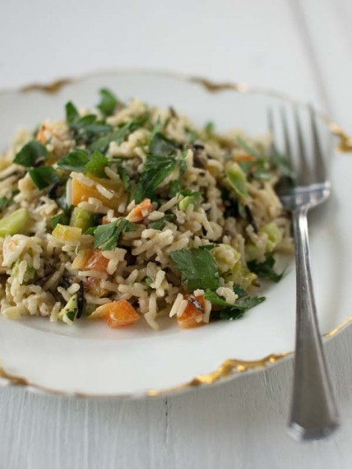
Parsley has long been known to take the corner seat on the edge of your plate, seen more as a garnish to highlight whatever is in the main meal. But I've grown to love its fresh, grassy flavor and I like using it as a main component when I'm cooking. The herb is also highly nutritious, containing high amounts of vitamins and antioxidant nutrients. I particularly enjoy the Italian flat-leafy variety; the leaves are more delicate than the curly ones and the taste less bitter.
When I created this salad, I was thinking of my husband. He is not a big fan of parsley, to him the flavor is overpowering and too grassy, so I was curious to see if I could win over his palate. I tossed together a couple different varieties of rice, bell peppers, and (my favorite) lemon-tahini dressing for a hearty salad. The result? He went for seconds.
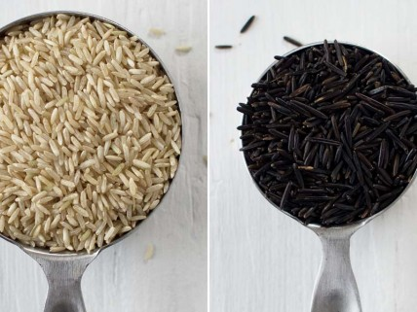
Wild Rice Salad with Lemon-Tahini Dressing
serves 4-6
1 cup brown rice
1/3 cup wild rice
2-2 1/4 cups water
2 small red and green bell peppers, seeded and finely chopped
1/2 bunch flat leaf parsley, roughly chopped
1/4 cup tahini
Juice of half a lemon
2-3 tablespoons tamari
1 tablespoon honey (agave if you're vegan)
2 tablespoons rice vinegar
In a medium saucepan combine 2 cups water, brown rice, and wild rice. Bring to a gentle boil, then reduce heat and cover. Cook for 30-45 minutes, adding more water if needed, until rice is tender. Once cooked, let cool for 5-10 minutes then fluff with a fork.
Mix the cooled rice with the bell peppers, and parsley.
In a small bowl, whisk together the tahini, lemon juice, tamari, honey, and rice vinegar. Pour the dressing over the rice. Serve or cover and refrigerate and serve chilled.
Jacquelyn Scoggin became a vegetarian at age 16 and has since been in the kitchen whipping up meals for her family and friends. She writes and photographs her love for vegetarian food on her blog, Good Things Grow. In 2009, she and her husband started Slide Sideways, a graphic design and handmade business. They maintain their love for the environment by using organic fabric, recycled paper, and environmentally friendly cleaning products.

